C2S Zahara
  - New Budget Functionality
  - March 2017

Table of Contents
Overview 3
Budget Manager 4
Creating a budget 4
Editing the budget details 5
Saving your budget scheme 5
Applying the budget 6
Multiple Budgets 6
Business Budget Settings 7
Checking performance against budget 8
Divisional budget performance 8
Checking budget when raising an Order 8
Project Budgets 10
Project budget reporting 10

Overview
- Budgets are now created in the Budget Manager
- Budgets can be set for Account Codes & Cost Codes
- Budgets can be applied against a Division or a Project
- Budgets can be downloaded, uploaded and created off line.
- Budgets can be annual, monthly, quarterly or weekly
- Budgets settings are in Business Settings
- Budget progress can be seen in the Division settings
- Budget awareness can be made available to both the Originator and the Approver
- Budget warnings, spend control, spend thresholds can all be set.

Budget Manager
The new Budget Manager is available from the Business menu, navigate into this.
https://myzahara.net/Budget
As part of the migration, if a Budget already existed, it will now show as shown in this management panel.

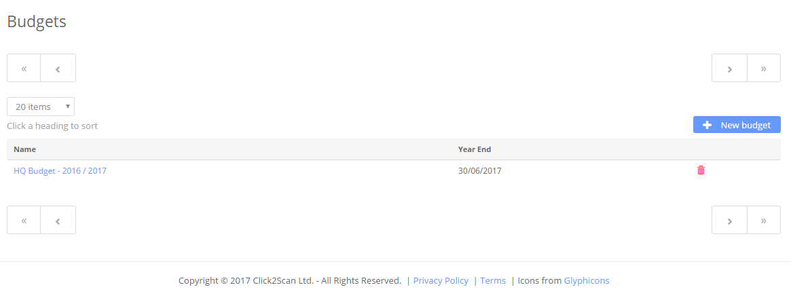
From this screen, you can create a new budget scheme or edit an existing budget.

Creating a budget
Budgets can be created for different reporting periods: week, month, quarter, year. Some specific options will be available for each, e.g. the day of the month to use for reset.
A budget can operate by nominal, cost code or absolute. Absolute is just a total measure of the money available without concern for the type of spend – most useful on a fixed cost project.
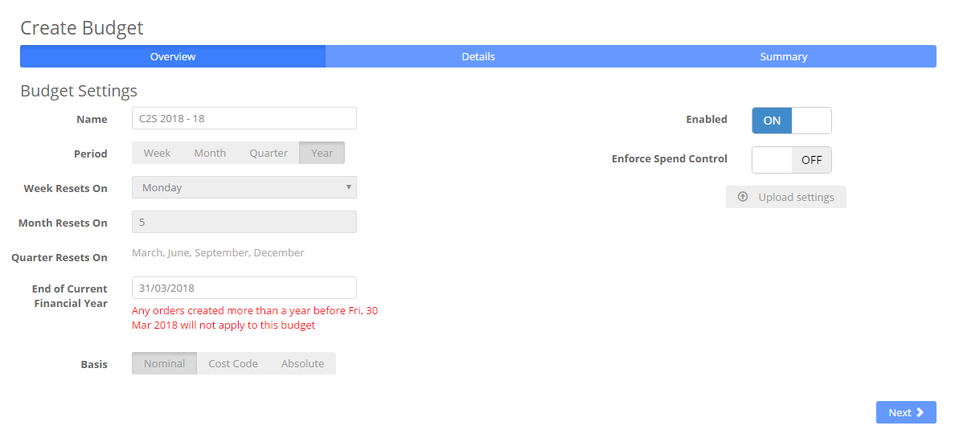
Figure 1 Creating a budget

Editing the budget details
Below is an example monthly budget by nominal code. We have added in just one line.
Initially the ‘per month’ box is all you see where you can enter a figure to be applied to all periods. You can also ‘Show all periods’ so you can add specific variations. For example an ice cream budget may increase in the summer months whereas energy would increase in the colder months.
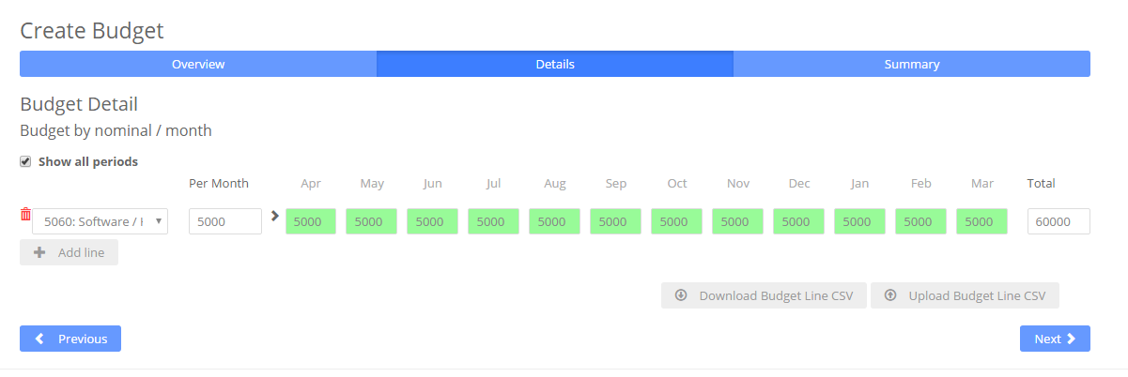
Figure 2 A monthly budget by nominal code
You can download and then upload the budget CSV to edit off-line and upload later. This makes it easy to crunch numbers in a spreadsheet where you might apply formulae to calculate your spend budget on other inputs such as the number of patients in a care environment.

Saving your budget scheme
On the third tab you can now ‘commit’ the budget (save it). This will immediately replace the budget settings on all associated entities (see Applying the budget).
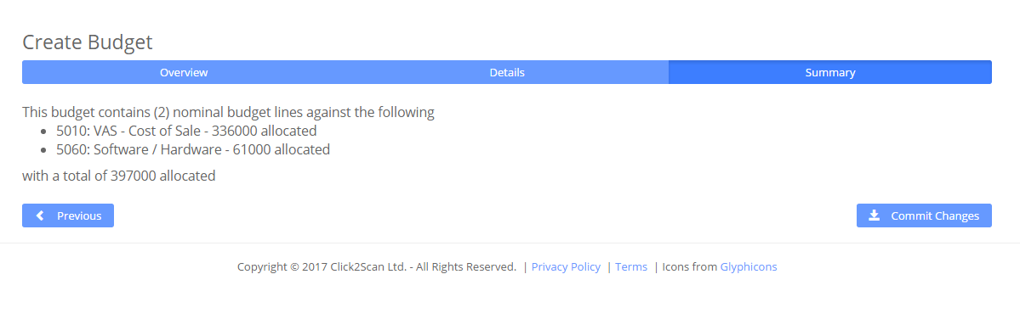
Figure 3 Saving the budget

Applying the budget
Once a budget has been created, you then have to apply it to a Division or a Project.
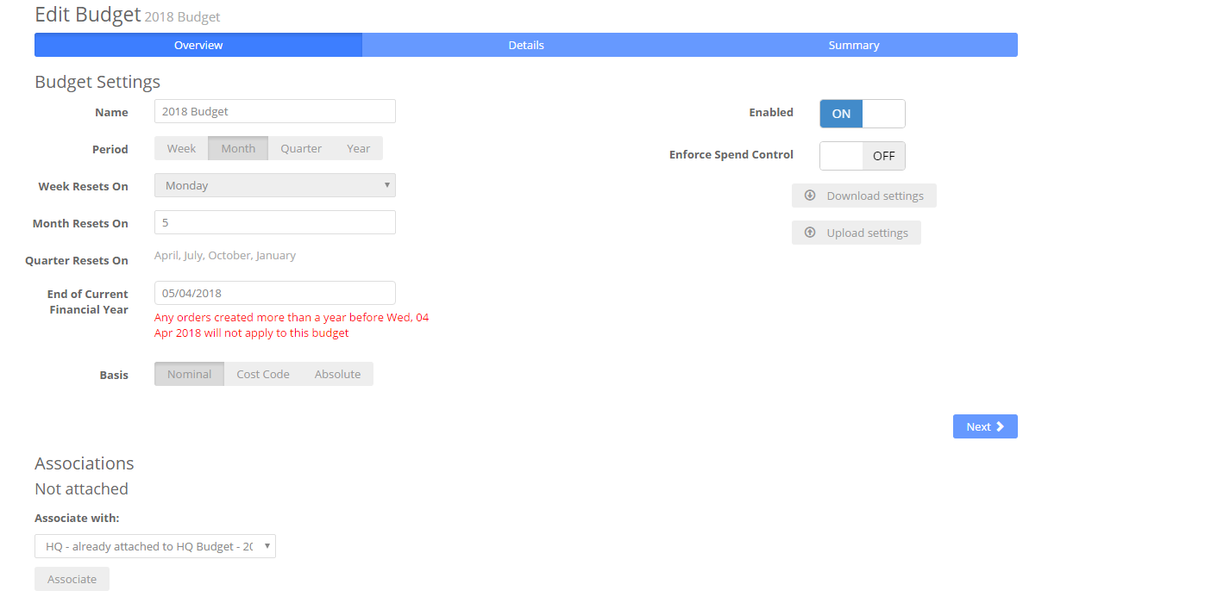
Figure 4 Associating a budget with a division / project
Click ‘Associations’ and choose projects or divisions you’d like to apply this budget scheme to. The same scheme can be applied to several ‘entities’.

Multiple Budgets
You can create as many budgets as you require but only one Budget per Division or Project in one time period can exist.

Business Budget Settings
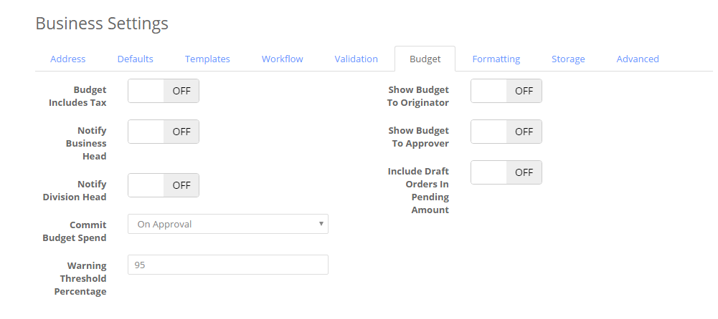
Figure 5 Business budget settings
There are a number of options you can set in the Business Unit > Settings > Budget:
Budget Includes Tax: | 5000 = 5000 including tax or 5000 excluding tax
Notify Business Head: | Send warning emails to the BU head if budgets are exceeded
Notify Division Head: | Send warning emails to the HOD if budgets are exceeded
Commit Budget Spend: | When is spend committed to the budget? On approval or send to the supplier.
Budget Warning: | The % of budget before we send emails off
Show Budget to Originator: | Display the Budget graphs to the originator as part of the raise order process
Show Budget to Approver: | Display the Budget graphs to the approver – on the Review screen - as part of the raise order process
Include Draft Orders in Pending amount: | Pending is the spend that’s currently in approval but not committed. You can include all Draft order in pending as well.

Checking performance against budget
There are 3 ways to check the budget performance.
- In the Division settings
- In the Project edit view
- As an Originator
- As an Approver

Divisional budget performance
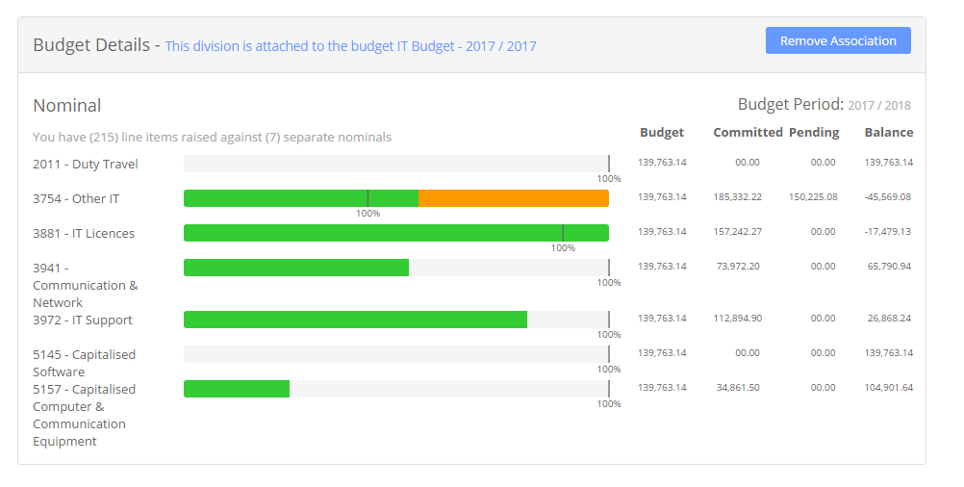
Figure 6 Checking division performance against budget
Green = Committed
Orange = Pending approval / on draft.

Checking budget when raising an Order
The Originator will raise their order and each line item has a warning as shown:
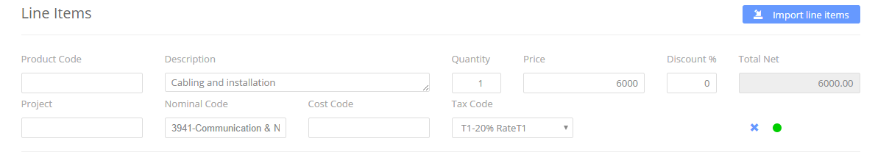
Figure 7 Budget awareness when raising an order
The green light shows that the Account code 3941 will allow the 6000 of spend.
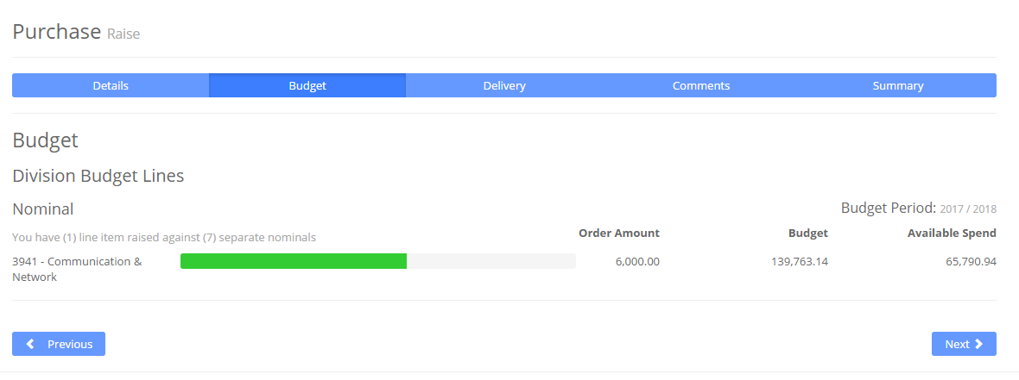
Figure 8 Summarised budget impact for a purchase
In the purchase budget analysis the summary of all lines is shown against budget.
The Approver will see the same budget analysis if they click the Review link in their approval email.

Project Budgets
Budgets can be applied to Projects in the same way as Divisions.
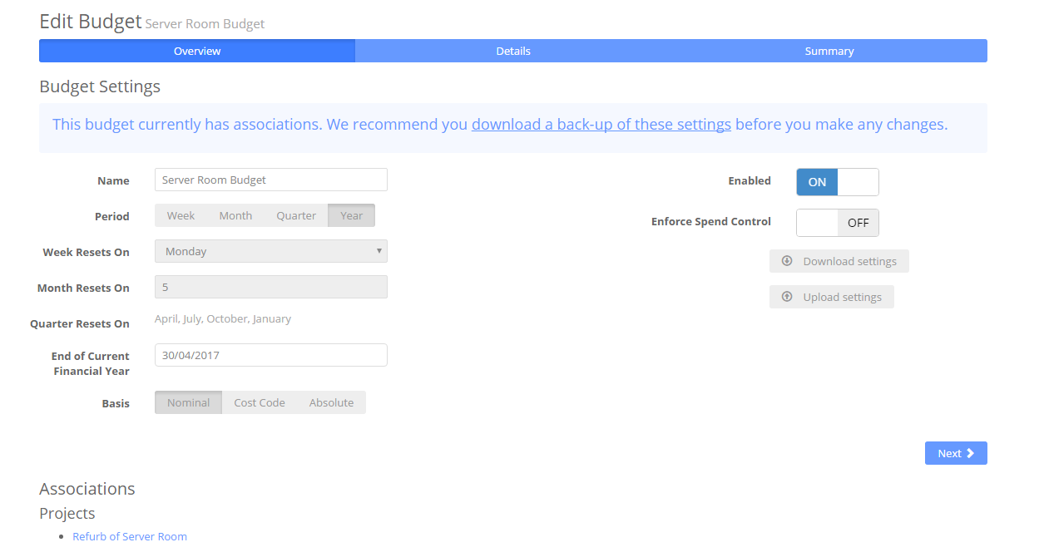
Figure 9 A budget applied to a project

Project budget reporting
Looking at the properties for a specific project you will see the same style of analysis as in a division.
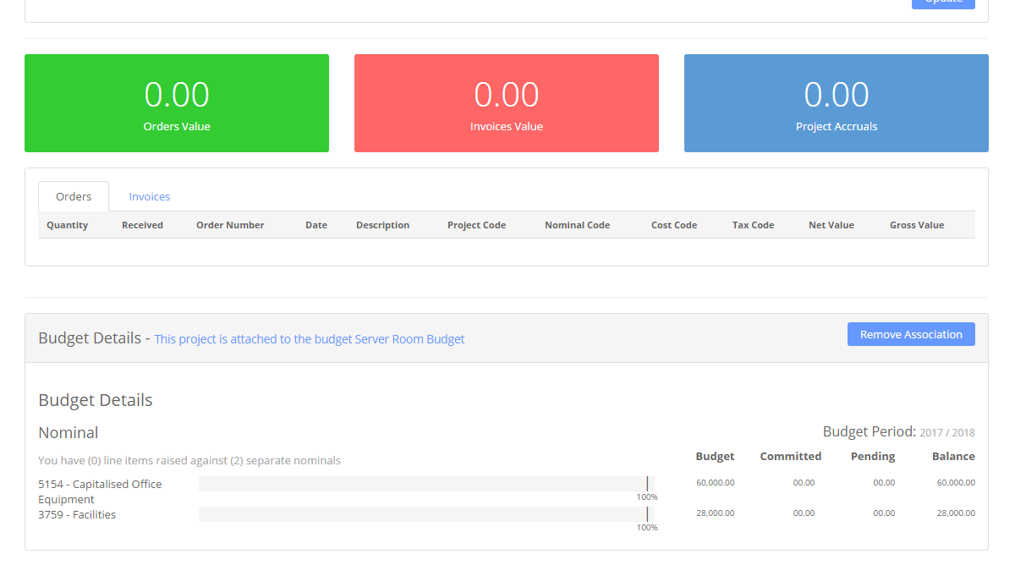
Figure 10 Project budget reporting
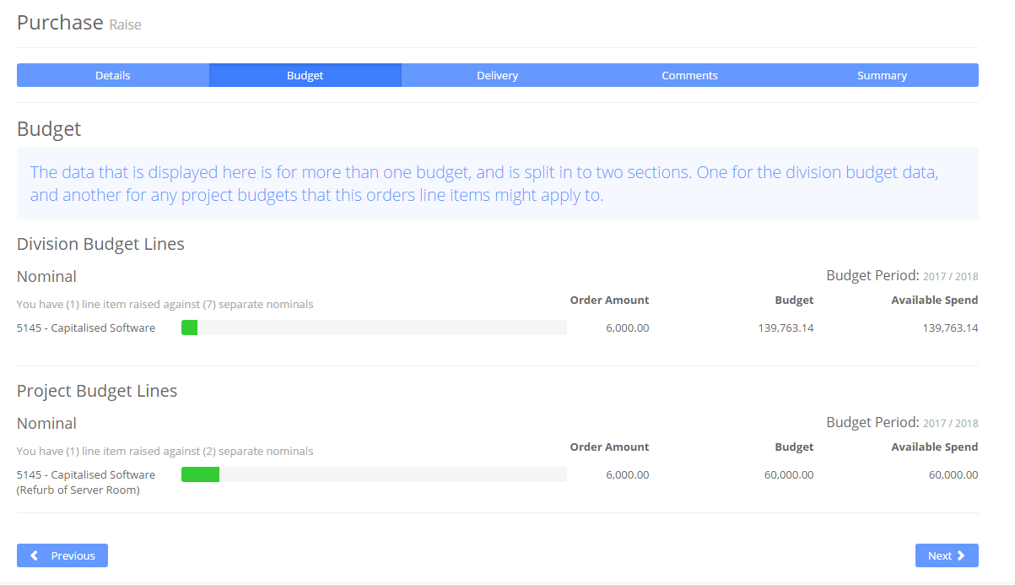
Figure 11 Purchase budget reporting when linked to a project

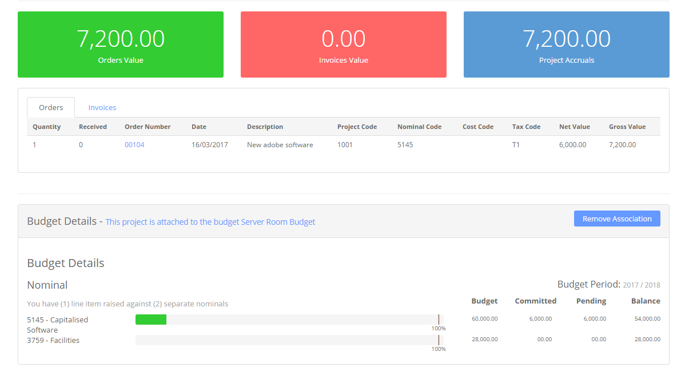
Figure 12 Project budget reporting (2)

